EXPERIENCE THE MAGIC OF ONLINE SCHOOLING WITH ELEARNING!
‍In today's world, the internet has become the go-to source for almost everything. You can find information about anything you need and get it at the tip of your fingertips. This includes education as well.
Online schooling, or eLearning, has become the new normal. It's convenient, fast, and easy to use. But what exactly is eLearning, and how can you make the most of it?


What is eLearning?
eLearning is the process of using digital technologies to facilitate learning. It is also known as online schooling, virtual learning, and distance learning.
It is a method of learning in which the instructor and student interact remotely and use digital tools such as computers, laptops, smartphones, and tablets to access educational materials.
eLearning has become increasingly popular in recent years due to its convenience, flexibility, and cost-effectiveness. It allows students to learn at their own pace and from the comfort of their own homes.
It also eliminates the need for physical classrooms, which saves time and money.
The main components of eLearning are the learning materials, the delivery system, and the assessment system. The learning materials can be either digital or printed and can include text, audio, video, or simulations.
The delivery system is the platform used to deliver the materials and can be anything from a web-based learning platform to a mobile app.
The assessment system is used to measure student performance, such as tests, surveys, and quizzes.
https://youtu.be/pXXWoRmu_jo

Benefits of eLearning
eLearning can offer many benefits to both students and instructors. The main benefit is that it allows students to learn at their own pace and in their own time.
Since there is no need to physically attend classes, students can fit their learning around their lives and schedule.
eLearning also eliminates the need to purchase textbooks and other materials. All the materials can be accessed online, which saves both time and money. Additionally, eLearning can offer a more interactive learning experience than traditional classroom learning.
With virtual tools such as video conferencing and screen sharing, instructors and students can be more engaged and connected with each other.
eLearning can also be beneficial for instructors as it can save them time by eliminating the need for physical classrooms. Additionally, instructors can use eLearning to track student progress and performance in real-time.
https://youtu.be/-cv_owDce80

eLearning Statistics
eLearning has grown exponentially in recent years, with the global eLearning market expected to reach $350 billion by 2025. Additionally, the number of students enrolled in online courses increased by over 6 million between 2015 and 2018.
The number of online courses available has also grown significantly. In 2018, there were over 17,000 online courses available on the Coursera platform alone.
This demonstrates the huge amount of opportunities available to students and instructors with eLearning.

eLearning Strategies
To make the most of eLearning, both students and instructors need to have a clear strategy. For students, this means setting goals and objectives, and creating a study plan.
It is important to plan ahead, set aside time for studying, and create a study environment that is both comfortable and conducive to learning.
Instructors should also have a clear strategy for teaching online. This includes developing course materials, deciding on the best delivery system, and creating an assessment system.
Additionally, instructors should provide regular feedback and support to students to ensure they stay motivated and on track.

Creating Your eLearning Plan
Creating an effective eLearning plan is the key to success. It is important to start by setting clear goals and objectives and deciding on the best delivery system.
Once you have these in place, you can create a study plan and create a comfortable and productive learning environment.
Your study plan should include the amount of time you plan to dedicate to studying each week, the materials you will need, and the learning objectives you want to achieve.
Additionally, you should plan regular breaks and set aside time for rest and relaxation.

eLearning Tips
There are some tips and tricks you can use to make the most of eLearning.
First, create a study schedule and stick to it. This will help you stay focused and motivated. Additionally, break down your learning objectives into smaller tasks so that you can focus on one thing at a time.
Second, create a comfortable and productive learning environment. Make sure you have access to all the materials you need, and that your workspace is distraction-free.
Third, take regular breaks and get enough sleep. This will help you stay energized and focused.
Finally, make sure to ask plenty of questions and get help if you need it. There are plenty of online resources and forums available to provide help and support.

The Best eLearning Platforms
The best eLearning platforms offer a variety of features to help make the learning experience more enjoyable and effective.
Coursera is one of the most popular eLearning platforms. It offers a wide range of courses and provides access to experts and mentors.
Additionally, it provides a library of resources to help students stay motivated and on track.
Udemy is another popular platform, with over 100,000 courses available. It also offers a variety of features such as video lectures, quizzes, and project-based learning.
Khan Academy is a great platform for those looking for free courses. It offers access to a wide range of courses in various subjects, and provides exercises and assessments to help students stay motivated.

Courses for Online Schooling
There are a variety of courses available for online schooling. These courses range from basic education courses to more advanced courses such as computer programming, web development, and data science.
For those looking to improve their knowledge in a particular subject, there are plenty of courses available. For example, Coursera offers a range of courses in subjects such as mathematics, economics, and finance.
Udemy also offers a wide range of courses in subjects such as business, marketing, and psychology.
For those looking to learn a new skill, there are a variety of courses available. For example, Coursera offers courses in coding, web development, and machine learning.
Udemy also offers courses in photography, graphic design, and video editing.

eLearning Services
There are a variety of services available to help you make the most of eLearning.
Tutoring services are a great way to get personalized help and support. You can find tutors who specialize in a variety of subjects and topics, and who can provide personalized feedback and guidance.
There are also services available to help you create and manage your eLearning plan. These services can help you stay organized and on track with your studies.
Finally, there are services available to help you assess your performance and track your progress.
These services can provide detailed insights into your performance and help you identify areas for improvement.
[caption id="" align="alignnone" width="820"]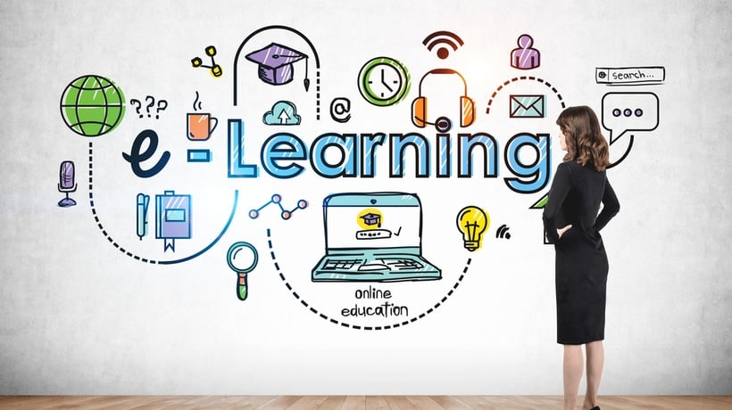 eLearning Services[/caption]

Conclusion
eLearning is a great way to access education from the comfort of your own home. It offers a range of benefits, such as convenience, flexibility, and cost-effectiveness.
Additionally, there are a variety of courses available to suit all needs, and a range of services to help you make the most of eLearning.
So, if you are looking to experience the magic of online schooling, eLearning is the way to go!

